

Team 6

Jonas Langer
Thomas Snowden
Emily Vorng
Tristan Sze
Brice Sanford

langerj@purdue.edu
tsnowden@purdue.edu
evorng@purdue.edu
tsze@purdue.edu
bsanfor@purdue.edu



Purpose 2
Introduction 2
Project Objectives 2
Requirements 2
Functional Requirements: 2
Nonfunctional Requirements: 5
Design Outline 7
Client-Server Model 7
System Components 7
Component Interactions 8
Design Issues 10
Functional Issues 10
Non-Functional Issues 12
Design Details 14
Data Class Level Design 14
Sequence Diagrams 14
Login 14
Sequence Diagrams 15
Login 15
Searching for Similar Songs 15
Leaving a Song Review 17
UI Mockups 18

Using headings
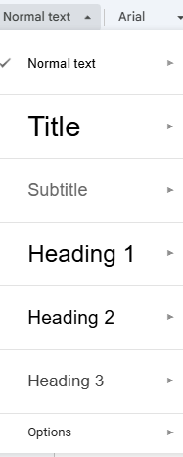

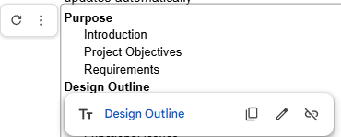
Hit refresh to update

Purpose

Introduction
Everyone listens to music, but most listeners lack an engaging way to interact with songs beyond simply pressing play. What if there was a way to share musical opinions, connect with like-minded listeners, and find the next song to be inspired by. Harmoniq addresses this need by creating a platform that does exactly that. Whether it's leaving ratings on a song, connecting with other users, or receiving personalized song recommendations, Harmoniq provides an interactive and engaging way for users to experience music beyond just listening.

Project Objectives
- Design a social web application that will allow users to share songs, playlists, and opinions with other music enthusiasts.
- Create a music recommendation engine that will allow users to find new songs that line up with their inputted song choices.
- Allow users to view a personalized feed with app-related updates from those they follow and connect with others through shared music tastes.

Requirements

Functional Requirements:
Accounts

ID | Function Requirement | Hours
1 | As a user, I would like to create my own Harmoniq Account. | 5
2 | As a user, I would like to login via a Google Account. | 8
3 | As a user, I would like to be able to change/update my username. | 2
4 | As a user, I would like to be able to change/update my password. | 1
5 | As a user, I would like to be able to delete my account. | 2

Social Features
ID | Function Requirement | Hours
6 | As a user, I would like to be able to follow other people’s accounts. | 3
7 | As a user, I would like to see a list of users who have sent me friend requests. | 3
8 | As a user, I would like to be able to see a list of users who I have sent a friend request to. | 2
9 | As a user, I would like to be able to set privacy levels for my account. | 5
10 | As a user, I would like to be able to leave a like on songs, which saves the song onto my profile. | 3
11 | As a user, I would like to leave a review on songs. | 3
12 | As a user, I would like to be able to see other people’s reviews on songs through their profile. | 3
13 | As a user, I would like to see what songs other people like. | 3
14 | As a user, I would like to click on the profile of the review and view their profile. | 3
15 | As a user, I would like to see when the review was posted. | 2
16 | As a user, I would like to leave a star rating on a song. | 2
17 | As a user, I would like to be able to pin playlists to the top of my profile. | 5
18 | As a user, I would like to see the average star rating on a song. | 4
19 | As a user, I would like to see what songs are trending based on recent likes and reviews. | 6
20 | As a user, I would like to see a personalized feed showing recent reviews and likes from people I follow. | 6

Song Data
ID | Function Requirement | Hours
21 | As a user, I would like to be able to search up songs by title. | 3
22 | As a user, I would like to be able to search up songs by artists. | 3
23 | As a user, I would like to be able to search up songs by genre. | 3
24 | As a user, I would like to be able to search up songs by bpm. | 3
25 | As a user, I would like to be able to search up songs by song writers. | 3
26 | As a user, I would like to be able to search up songs by album. | 2
27 | As a user, I would like to be able to search up songs by singles by an artist. | 5
28 | As a user, I would like to be able to search up songs by star rating. | 4
29 | As a user, I would like to be able to search up and filter it by if it is listened to or not. | 5
30 | As a user, I would like to be able to search up and filter it by if it is liked. | 4
31 | As a user, I would like to be able to import a song with the song details. | 8
32 | As a user, I would like to be able to propose edits to a song's details if I uploaded it. | 4
33 | As a user, I would like to delete the song's details if I uploaded it. | 4
34 | As a user, I would like the form to tell me if the form is missing data. | 3
35 | As a user, I would like to be able to mark the song as listened to before or not. | 5
36 | As a user, I would like to be able to mark songs to listen to later. | 3

Recommendation Engine
ID | Function Requirement | Hours
37 | As a user, I would like to be able to input a target song for the recommendation engine. | 10
38 | As a user, I would like to be able to filter similar songs by similar bpm. | 4
39 | As a user, I would like to be able to filter similar songs by song writers. | 3
40 | As a user, I would like to be able to filter similar songs by artist. | 3
41 | As a user, I would like to be able to filter similar songs by genre. | 4
42 | As a user, I would like to be able to filter similar songs by album. | 3
43 | As a user, I would like to be able to filter similar songs by star rating. | 3
44 | As a user, I would like a randomize button that gives me a random song. | 2
45 | As a user, I would like to mark whether the recommendation was helpful or not. | 3

Playlists
ID | Function Requirement | Hours
46 | As a user, I would like to be able to create playlists so that I can organize songs. | 5
47 | As a user, I would like to be able to add or remove songs from playlists so that I can manage my collections. | 4
48 | As a user, I would like to be able to delete a playlist so that I can remove playlists I no longer use. | 4
49 | As a user, I would like to generate a playlist based on similar songs. | 8
50 | As a user, I would like to be able to add whole albums to my songs. | 8

Additional
ID | Function Requirement | Hours
51 | As a user, I would like to be able to easily share my profile via a unique link. | 8
52 | As a user, I would like to be able to visit a FAQ page where I can get answers to frequently asked questions. | 2
53 | As a user, I would like to be able to reference a tutorial so I can be more familiar with the app. | 2

Nonfunctional Requirements:

Performance
Harmoniq will be designed to provide fast and responsive interactions for users. Common user actions such as loading the homepage, searching for songs, viewing playlists, and submitting reviews should complete within a reasonable response time under normal usage.

The application will optimize performance by minimizing unnecessary network requests, using efficient database queries, and applying caching where appropriate. The frontend will leverage asynchronous data loading to prevent blocking the user interface, ensuring smooth navigation and minimal perceived latency.

Usability
Harmoniq will be designed to provide an intuitive and user-friendly experience optimized for desktop devices. The interface will feature clear navigation and consistent layouts, allowing users to easily discover music, manage playlists, and interact with other users.

The homepage will display recent reviews and trending playlists to help users quickly find relevant information. Search and filtering tools will be clearly accessible to support efficient discovery of songs and artists. It will be designed to minimize the learning curve for new users.

Scalability
Harmoniq will be designed to support a growing user base and increasing activity. Initially, the system should be able to handle dozens of concurrent users with minimal latency, with the ability to scale as demand increases.
To support scalability, the application will utilize efficient database indexing and caching to improve query performance and reduce load on the database. The backend architecture will be designed to allow horizontal scaling, enabling additional server instances to be added if traffic increases. The system will be deployable on cloud infrastructure that supports traffic distribution and resource scaling as needed.
Security
Harmoniq will be designed to protect user data and ensure a safe user experience. Users will be able to control their privacy settings and choose whether their profiles, playlists, and activity are public or private. Users may follow or unfollow other users at any time, and private content will only be visible to authorized users.
The frontend will be built using React, which automatically escapes rendered content to reduce the risk of cross-site scripting (XSS) attacks. All communication between the client and server will occur over encrypted HTTPS connections to protect sensitive data.
The backend will be implemented using Node.js and Express, enforcing access control so users may only modify their own data. Server-side validation will be used to prevent malformed or malicious requests and protect against common web vulnerabilities.

Design Outline

Client-Server Model
Harmoniq follows a client-server architecture typical to web applications. The frontend client will be built with React and will communicate with the backend server which uses Node and Express. This communication will occur through RESTful API calls done over HTTPS. The backend will be responsible for processing incoming requests, performing authentication, and interacting with the relational database to return structured responses to the client. The client will then need to update the user interface dynamically based on the response data. Google OAuth is used as an external authentication provider to securely verify user identity.
Each component will be modular and independently maintainable. The frontend handles presentation and user interaction, the backend will enforce business logic and data protection, and the database will be responsible for maintaining persistent storage. External services that are used will be isolated from the core application logic.

System Components
Frontend Client
- Will be constructed using React.js
- Provides the user interface for browsing songs, managing playlists, viewing profiles, and interacting socially with other users
- Sends RESTful API requests to the backend
- Handles client-side validation for forms (login, song imports, ratings)
- Receives responses and dynamically updates content / renders data
- Stores authentication tokens securely for session management

Backend Server
- Handled with Node.js and Express.js
- Exposes RESTful API endpoints for users, songs, playlists, reviews, and recommendations
- Handles authentication via Google OAuth token validation
- Performs server-side validation on all of the incoming requests
- Executes business logic such as but not limited to feed generation, recommendation filtering, updating ratings/playlists.
- Communicates securely with the relational data store to enforce integrity.

Relational Database
- Likely a PostgreSQL data storage or similar equivalent (ie Supabase)
- Stores structured application data for all relevant classes
- Enforces data integrity using foreign keys and constraints
- Supports indexing for efficient filtering and searching to optimize performance

External Services
- Google OAuth used to authenticate users securely without requiring password storage.

Here is a high-level overview of the interactions between components with their various responsibilities listed. For more details reference the flow diagrams later in this outline.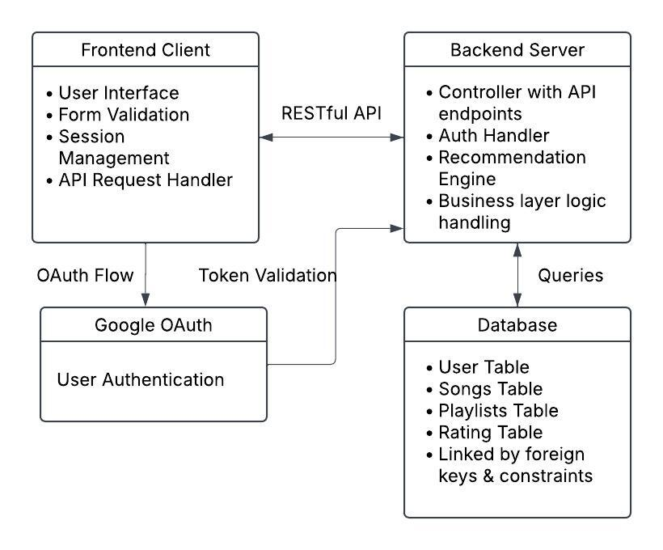

Component Interactions
Here is a high-level overview on how some of our components may interact throughout the system. The interactions listed below are some of the most important but do not account for every possible interaction the system will be responsible for handling.

User Authentication
The frontend will prompt users to login via Google. The Google OAuthhandle credential verification externally and returns an ID token. The frontend will send this token to the backend which is used to validate the user. If the user exists in the database it retrieves the account information, otherwise creates a new record in the database. The backend then issues a session token to the frontend allowing authenticated requests.

User Actions
The user performs an action such as liking a song, following another user, or posting a review. The frontend sends a RESTful API request to the backend with the session token needed for authentication. The backend will validate the request and the token before enforcing strict business rules and updating the database with the new information. The backend can then respond with a success or failure message and any associated data. The frontend will process this information and make updates to the UI to reflect the new state of the application.

Data Retrieval
The user requests data for instance searching for a specific song. The frontend will send a GET request to the backend with the session token. The backend will need to authenticate the user before querying the database for relevant records. It might apply caching or aggregation during this step to improve the database performance. Once finding said records, the backend will return structured response to the frontend which the frontend will need to parse to render the relevant information for the user.

Song Recommendations
Users request a song recommendation passing input to the engine. The backend will authenticate this user, retrieve the relevant song data, and apply the algorithms from the engine. The backend will return the recommended song produced by the engine to the frontend. The frontend will need to display the recommendation result dynamically to the user for best experience.

Design Issues

Functional Issues
How should users create accounts in Harmoniq?
Options:
- Google OAuth
- Email and Password
- Support both Google OAuth and email/password

Decision: Google OAuth only

We are choosing to implement Google OAuth as the sole authentication method to simplify the authentication process, improve security, and reduce the overall development complexity. Google OAuth eliminates our need to manage password storage, resets, and credentials significantly lowering the risk of breaches related to improperly stored passwords. By delegating authentication to Google, we rely on a trusted, industry standard identity provider that implements robust security measures such as 2FA, bot detection, and account recovery systems.

From a usability standpoint, Google reduces friction during sign-up/login by streamlining the process through their existing credentials. In regards to development, limiting authentication to solely Google OAuth will reduce implementation time and maintenance overhead. The team will be able to spend more time on the important features than handling user account information. Down the line, these other sign-in options can be added as quality of life features.

How granular should user privacy settings be?
Option:
- Fully public profiles
- Fully private profiles
- Configurable levels of privacy

Decision: Configurable levels of privacy

Harmoniq includes social features like following, reviewing, and visiting a personalized feed. A configurable privacy model allows users to control the visibility of their content based on their personal preferences. This will increase user trust and improve the usability of the platform on an everyday basis.

How should song recommendations be generated?
Options:
- Rule-based filtering (BPM, genre, artist, etc)
- Collaborative filtering (based on similar users)
- Hybrid model combining a and b

Decision: Rule-based filtering initially with opportunity to scale to the hybrid model

Given the project scope and the time constraints, rule-based filtering is a more feasible approach. Our main concern is creating an engine that will help users find their next big song. Hence, it should be the priority to establish the initial functioning engine with the rule-based filters before adding additional qualities that might tune its performance or accuracy. The architecture should allow for future expansion toward collaborative filtering even if it is not adopted.

How should song search functionality be implemented?
Options:
- Simple SQL queries using commands such as LIKE
- Full-text search indexing in the database
- Dedicated search engineers (e.g. Elasticsearch)

Decision: Full-text search indexing

Full-text search provides better performance and more relevant results than simple LIKE queries offer. While there are undeniable benefits to dedicated search engineers such an engine is likely excessive for the scale of the current project. Indexed search will balance performance and system complexity, allowing the development team to spend more time working on Harmoniq’s core features. In the future, the search design can be refactored as needed to best support the application and its users.

How should the personalized feed be generated?
Option:
- Real-time query of followed / public user’s activities
- Precomputed feed (periodic background processing)
- Event-driven feed updates using message queues

Decision: A precomputed feed

Real-time aggregation can naturally become extremely expensive as the number of users on the platform scales. While an event driven feed architecture is powerful and highly scalable it introduces architectural complexities that increase deployment complexity, operational overhead, and debugging difficulty. In addition, event-driven systems seem to be most beneficial when handling high traffic volumes or near real-time activity streams. Harmoniq will feature things like reviews, likes, and playlists from users which do not require millisecond-level propagation. A short delay in this case should be acceptable. The precomputed feed generated at regular intervals (or triggered after certain activities) will balance performance with practicality for this project.

Non-Functional Issues

What type of database should store user and song data?
Options:
- NoSQL database
- Relational database
- Hybrid database architecture

Decision: relational database
Harmoniq includes well-structured and highly relational data such as users, followers, playlists, songs, likes, and reviews. These entities have clearly defined relationships, including many-to-many relationships (e.g., users liking songs, users following other users). A relational database is well-suited for modeling these relationships using foreign keys, join tables, and indexing. It also enforces strong data integrity through constraints, which is important for maintaining consistency when users update profiles, delete accounts, or modify playlists.
A NoSQL database is typically better suited for unstructured or rapidly changing data models, which does not align with Harmoniq’s clearly defined schema. Additionally, core features such as calculating average ratings, trending songs, and personalized feeds rely on aggregations and joins that relational databases handle efficiently. A hybrid approach would add unnecessary architectural complexity without clear benefits at this stage.
How should the backend enforce data protection?
Options:
- Client side validation only
- Server side validation only
- Both client and server side validation

Decision: both validation types
Client-side validation improves user experience by providing immediate feedback, such as alerting users when required fields are missing or inputs are improperly formatted. This reduces unnecessary network requests and makes the application feel more responsive. However, client-side validation alone is not secure because it can be bypassed by modifying requests or interacting directly with the API. Therefore, all critical validation and authorization checks must also be enforced on the server. The backend will verify user identity, ensure users can only modify their own data, validate request structure, and prevent malicious or malformed inputs. Using both validation layers ensures strong security while maintaining a smooth and user-friendly interface

How should performance bottlenecks be minimized?
Options:
- No optimization until scaling becomes an issue
- Use indexing and caching strategically
- Heavy caching for all endpoints
Decision: strategic indexing and caching

Rather than delaying optimization or applying heavy caching to all endpoints, Harmoniq will use indexing and caching selectively where they provide the most impact. Database indexing on frequently queried fields such as song title, artist, genre, and user IDs will significantly improve search performance and relational queries as the dataset grows. Additionally, selective caching will be applied to expensive or frequently accessed data such as trending songs, average star ratings, and possibly personalized feeds. These values do not change constantly, making them suitable for short-term caching to reduce repeated database load. Fully caching all endpoints would introduce unnecessary complexity, cache invalidation challenges, and the risk of stale data. A strategic approach provides meaningful performance gains while keeping simplicity.

How should reviews and user-generated content be moderated?
Options:
- No moderation
- Manual admin moderation
- User reporting + admin review

Decision: Reporting and admin review

Because users can leave reviews, and their own content, moderation will be a necessity. A reporting system scales better than manual proactive review and maintains integrity of the platform for all users.

Design Details

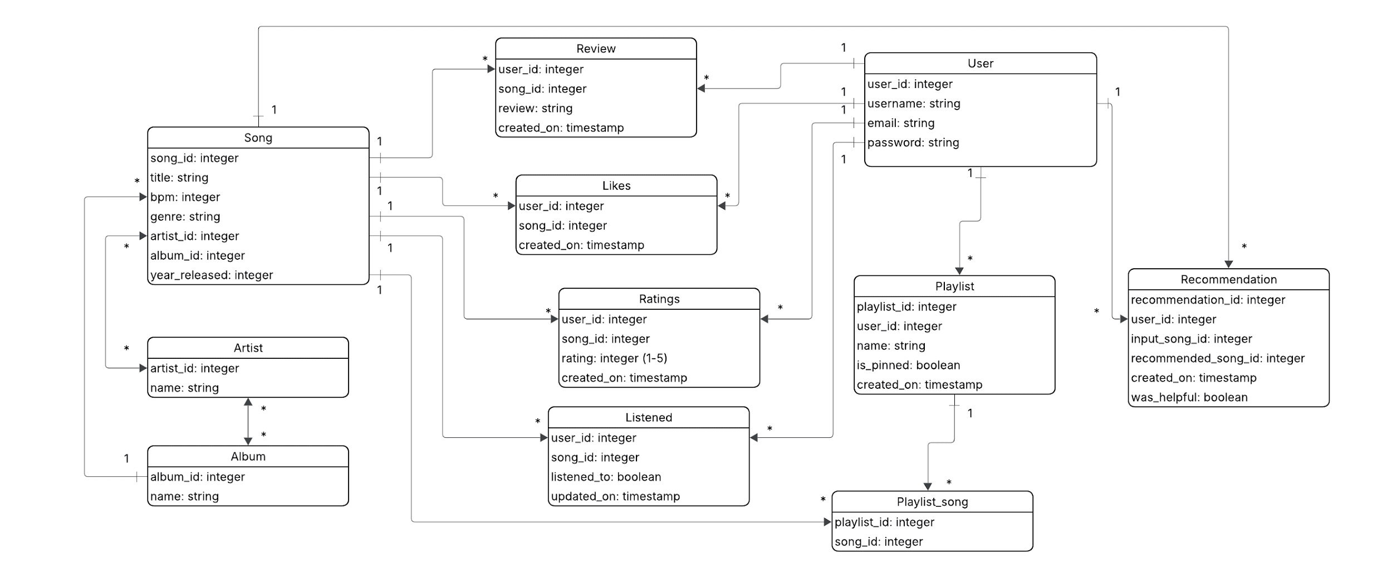
Data Class Level Design

Sequence Diagrams

Login
This diagram shows the sequence of events that will run when a user attempts to login. When the user presses the login button they will be redirected to the login screen. Once they fill in their information our client will send a request to our server to authenticate their information. Our server will check the login data with the database to validate the credentials. The client will then redirect the user to the main page.

Description of Classes and Class Interactions:
User:
- Someone who creates an account on Harmoniq is added as a user.
- The user class stores their information such as user_id, username, email, and password.
- A user can interact with a song by liking, reviewing, rating, listening, or adding it to a playlist.
- A user can create, edit, or delete their playlists.
- A user has a one to many relationship with the reviews, likes, playlists, and listened.
Song:
- The song class stores the data for each song such as song_id, title, bpm, genre, year_released, artist and album ids.
- A song has a many to many relationship with artist.
- A song belongs to only one album.
- A song has one to many relationships with review, likes, ratings, and listened.
- A song is used as input to receive recommendations and generate playlists.
Artist:
- The artist class contains an artist_id, and their name.
- An artist has a many to many relationship with songs.
- An artist has a many to many relationship with album.
Album:
- The album class contains an album_id, and its name.
- An album has a many to many relationship with artist.
- An album has a one to many relationship with songs.
Review:
- The review class stores the user’s written review for a song.
- It contains the written review and time it was written.
- A review belongs to only one user and to one song.
- Reviews will show up on the songs page for users to read.
Like:
- The like class stores when a user likes a song
- It contains the time when they like the song.
- A like belongs to only one user and to one song.
- Likes can be used to determine which songs are trending.
- Total likes will be displayed for each song.
Ratings:
- The ratings class allows the user to rate the song 1-5 stars.
- It contains the star rating and the time it was given.
- A rating belongs to only one user and to one song.
- Ratings will be used to find the average score of a song and be displayed by each song.
Listened:
- The listened class allows the user to make a song as listened to.
- It contains whether or not they have listened to it and when they listened to it
- A listened status belongs to only one user and to one song.
- The total users that have listened will show up on a songs page
Playlist:
- A playlist is a collection to songs created by the user.
- It contains the playlist name, when is was created, and whether it is pinned to the user profile
- A playlist only has one user.
- It has a one to many relationship with playlist_song, which stores the songs in the playlist
Playlist_song:
- Join the playlist and song classes together.
- Contains the id of the playlist and the id of the songs in the playlist.
Recommendation:
- The recommendation classes recommends songs based on a users preference or a given song
- It contains the given songs id, the recommended songs id, and when it was created.
- It also allows users to decide if the recommendation was helpful or not with a boolean.

Sequence Diagrams

Login
This diagram shows the sequence of events that will run when a user attempts to login. When the user presses the login button they will be redirected to the login screen. Once they fill in their information our client will send a request to our server to authenticate their information. Our server will check the login data with the database to validate the credentials. The client will then redirect the user to the main page.

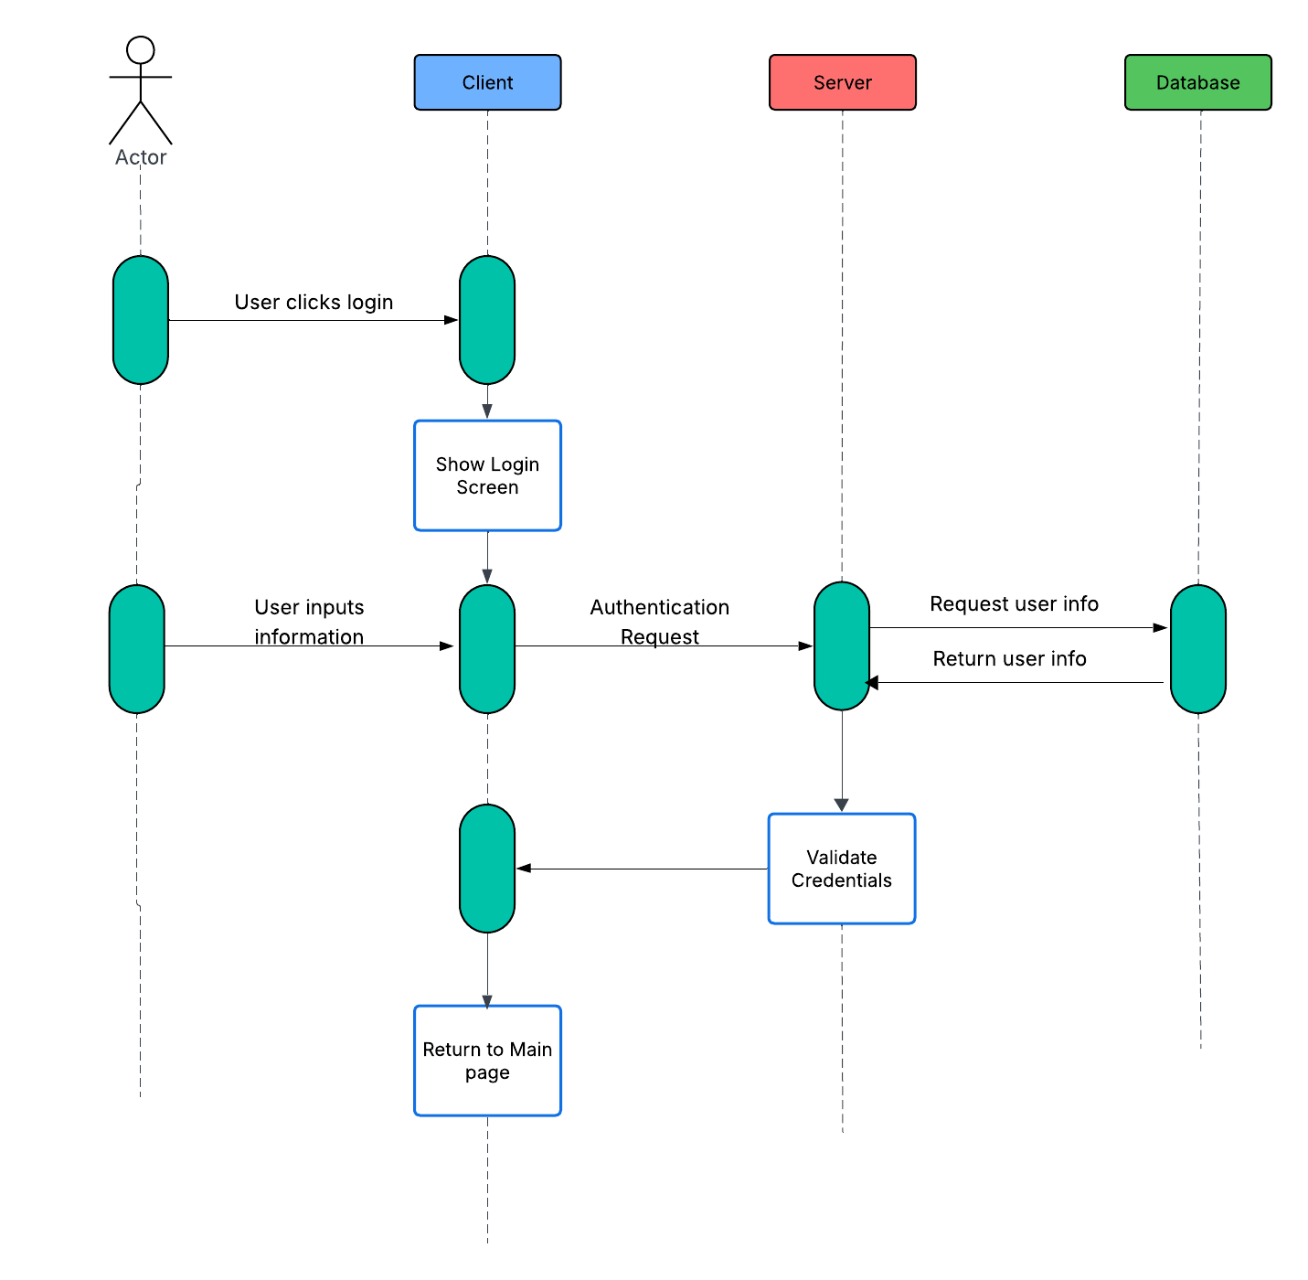

Searching for Similar Songs
This diagram shows the sequence of events that will run when a user attempts to search for a similar song. The user will search for a song, which will get sent to the server to check the database for songs that match the query. The client will show the user the matching songs. The user is able to choose the target song, and what characteristics they would like to filter the similar songs by. The server will request songs from the database by matching characteristics and organize which songs match the criteria. The client will then show the user a list of matching similar songs.
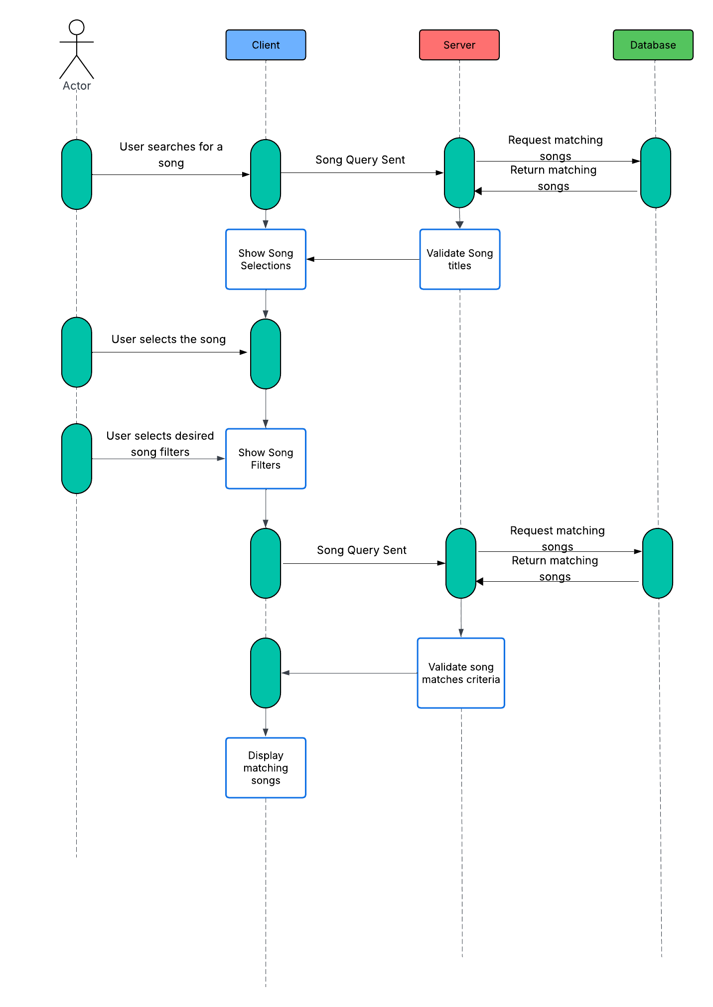

Leaving a Song Review
This diagram shows the sequence of events that will run when a user attempts to leave a song review. The client will prompt the user for information that the user would like to leave on the song. The client will then return that information to the server, where the server will store the song into the database. The server will then collect the data from the database to update the song’s current ratings and add the review. The client will then show the user the updated page with their review.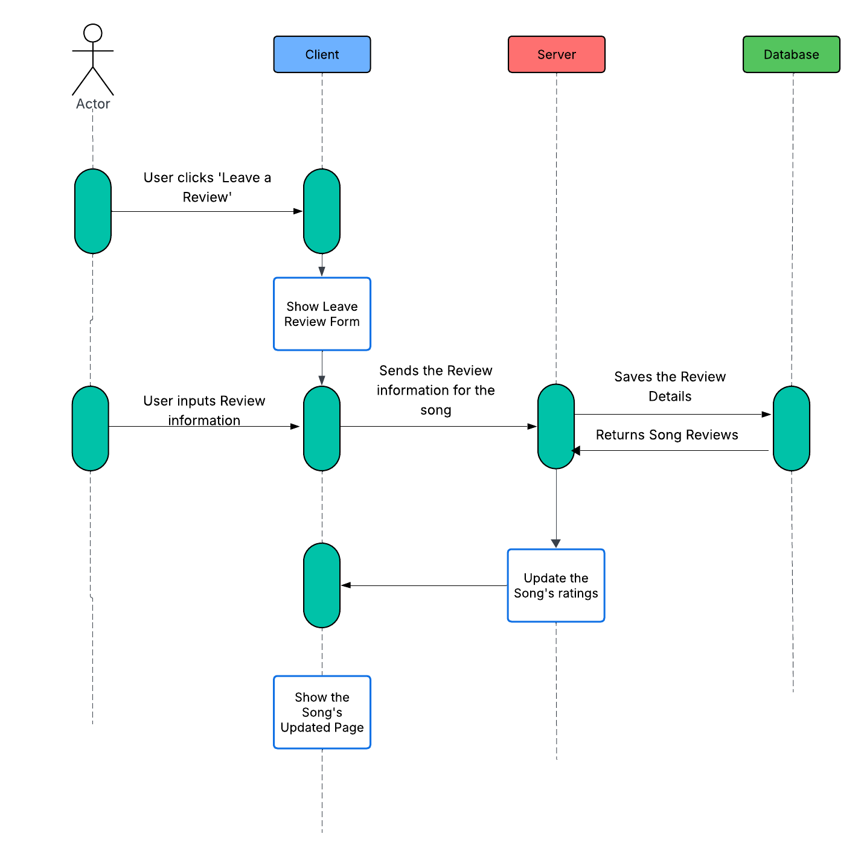

UI Mockups

Start screen
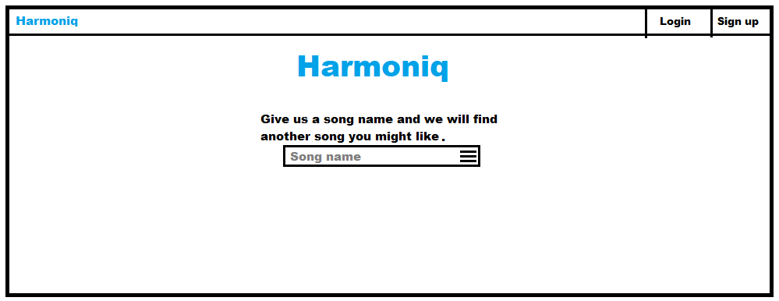
First screen people see when they go to the website. Allows people to insert a song and find another similar to it and with the three lines button on the right they can filter it. The top left logo when clicked will always bring you back to this page. Also has a login and sign up button in the corner that will change to the person's account if they are logged in.
Login screen
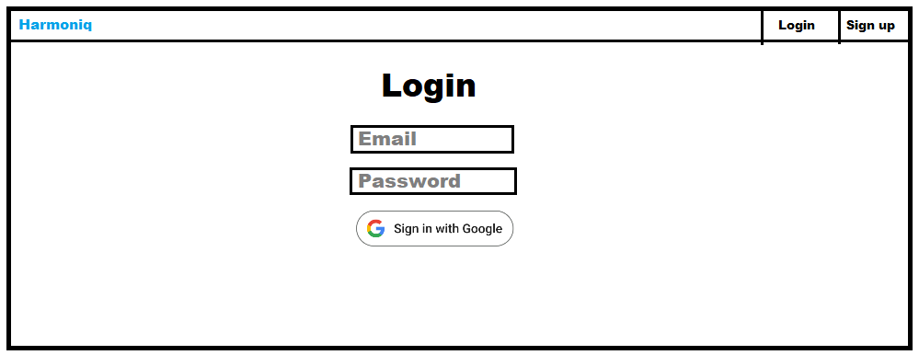

Showing a found song
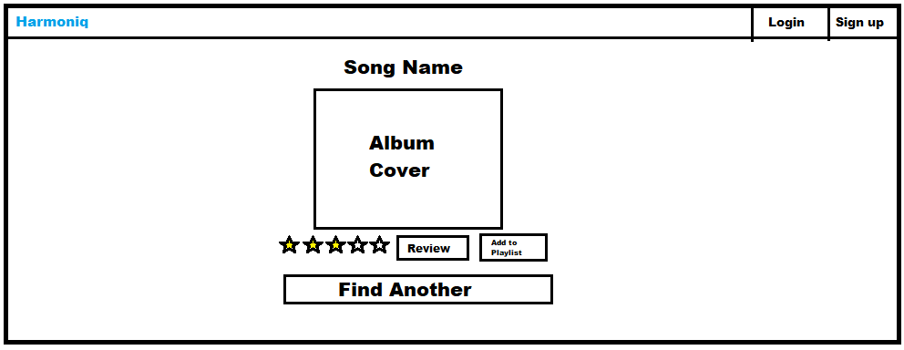
Hitting any of the stars, review, or add to playlist buttons while not logged in will ask a user to sign up.
Reviews
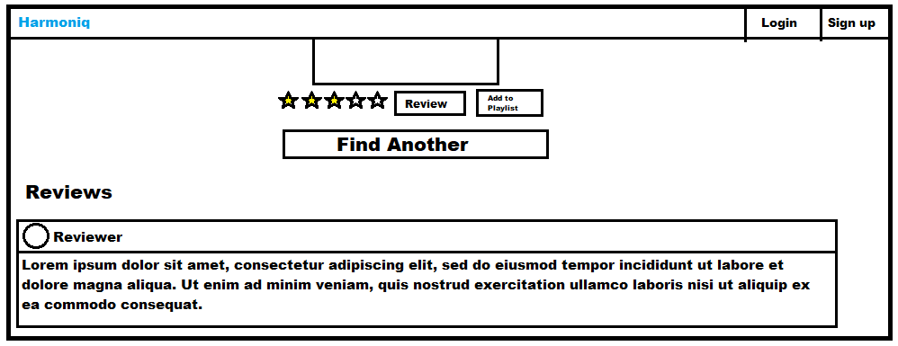
After scrolling down from a recommended song you can see users’ reviews.

Account Page
